**Independent Work App**



**SUBMITED**

**TO**

**GUJARAT UNIVERSITY**

**&**

**C.U. Shah Institute Of Computer Application**

**Independent Work App**

**A PROJECT REPORT**

**On**

**Independent Work App**

**SUBMITED TO**

**GUJARAT UNIVERSITY**

**For partial Fulfillment Degree of**

**Bachelor of Computer Application (BCA)**

**SEM – 5 Software Development Project – 1**

**Submitted By :**

**KOLIPATEL PRAGNESH VINODBHAI**

**KUMBHANI KRUSHALI DINESHBHAI**

**RATHOD KRUPESH SANJAYBHAI**

**C.U. SHAH INSTITUTE OF COMPUTER APPLICATION**

**ASHRAM ROAD,AHMEDABAD – 380014**

Website:https://[www.cushahbca.ac.in](http://www.cushahbca.ac.in/) Contact No:+91635-925-9669

Year 2022-2023

**C.U SHAH INSTITUTE OF COMPUTER APPLICATION**

Near Gujarat Vidyapith, Income Tax Circle, Ashram Road, Ahmedabad-382330

[Email](mailto:-cushahbca@gmail.com) [:](mailto:-cushahbca@gmail.com) [cushahbca@gmail.com](mailto:-cushahbca@gmail.com) Contact no : +635-925-9669

**Certificate of Completion**

This is Certify that the following student of C.U. SHAH Institute of Computer Applications, Ahmedabad-14 from BCA semester V(Ty BCA) have satisfactory completed software development project PART 1 on

**“Independent Work App”**

As An Academic Requirement of BCA Semester-V as a partial fulfillment of the requirement for the degree of Computer Application (BCA) for the Academic year 2022-23.

**Name of Student Roll No.(College) Seat No.(University)**

KOLIPATEL PRAGNESH V. 3061

KUMBHANI KRUSHALI D. 3064

RATHOD KRUPESH S. 3152

Prof. Nilam Shrimali Dr. Brijesh Bhatt

(Internal guide) (I/C Principal) (External Examiner)

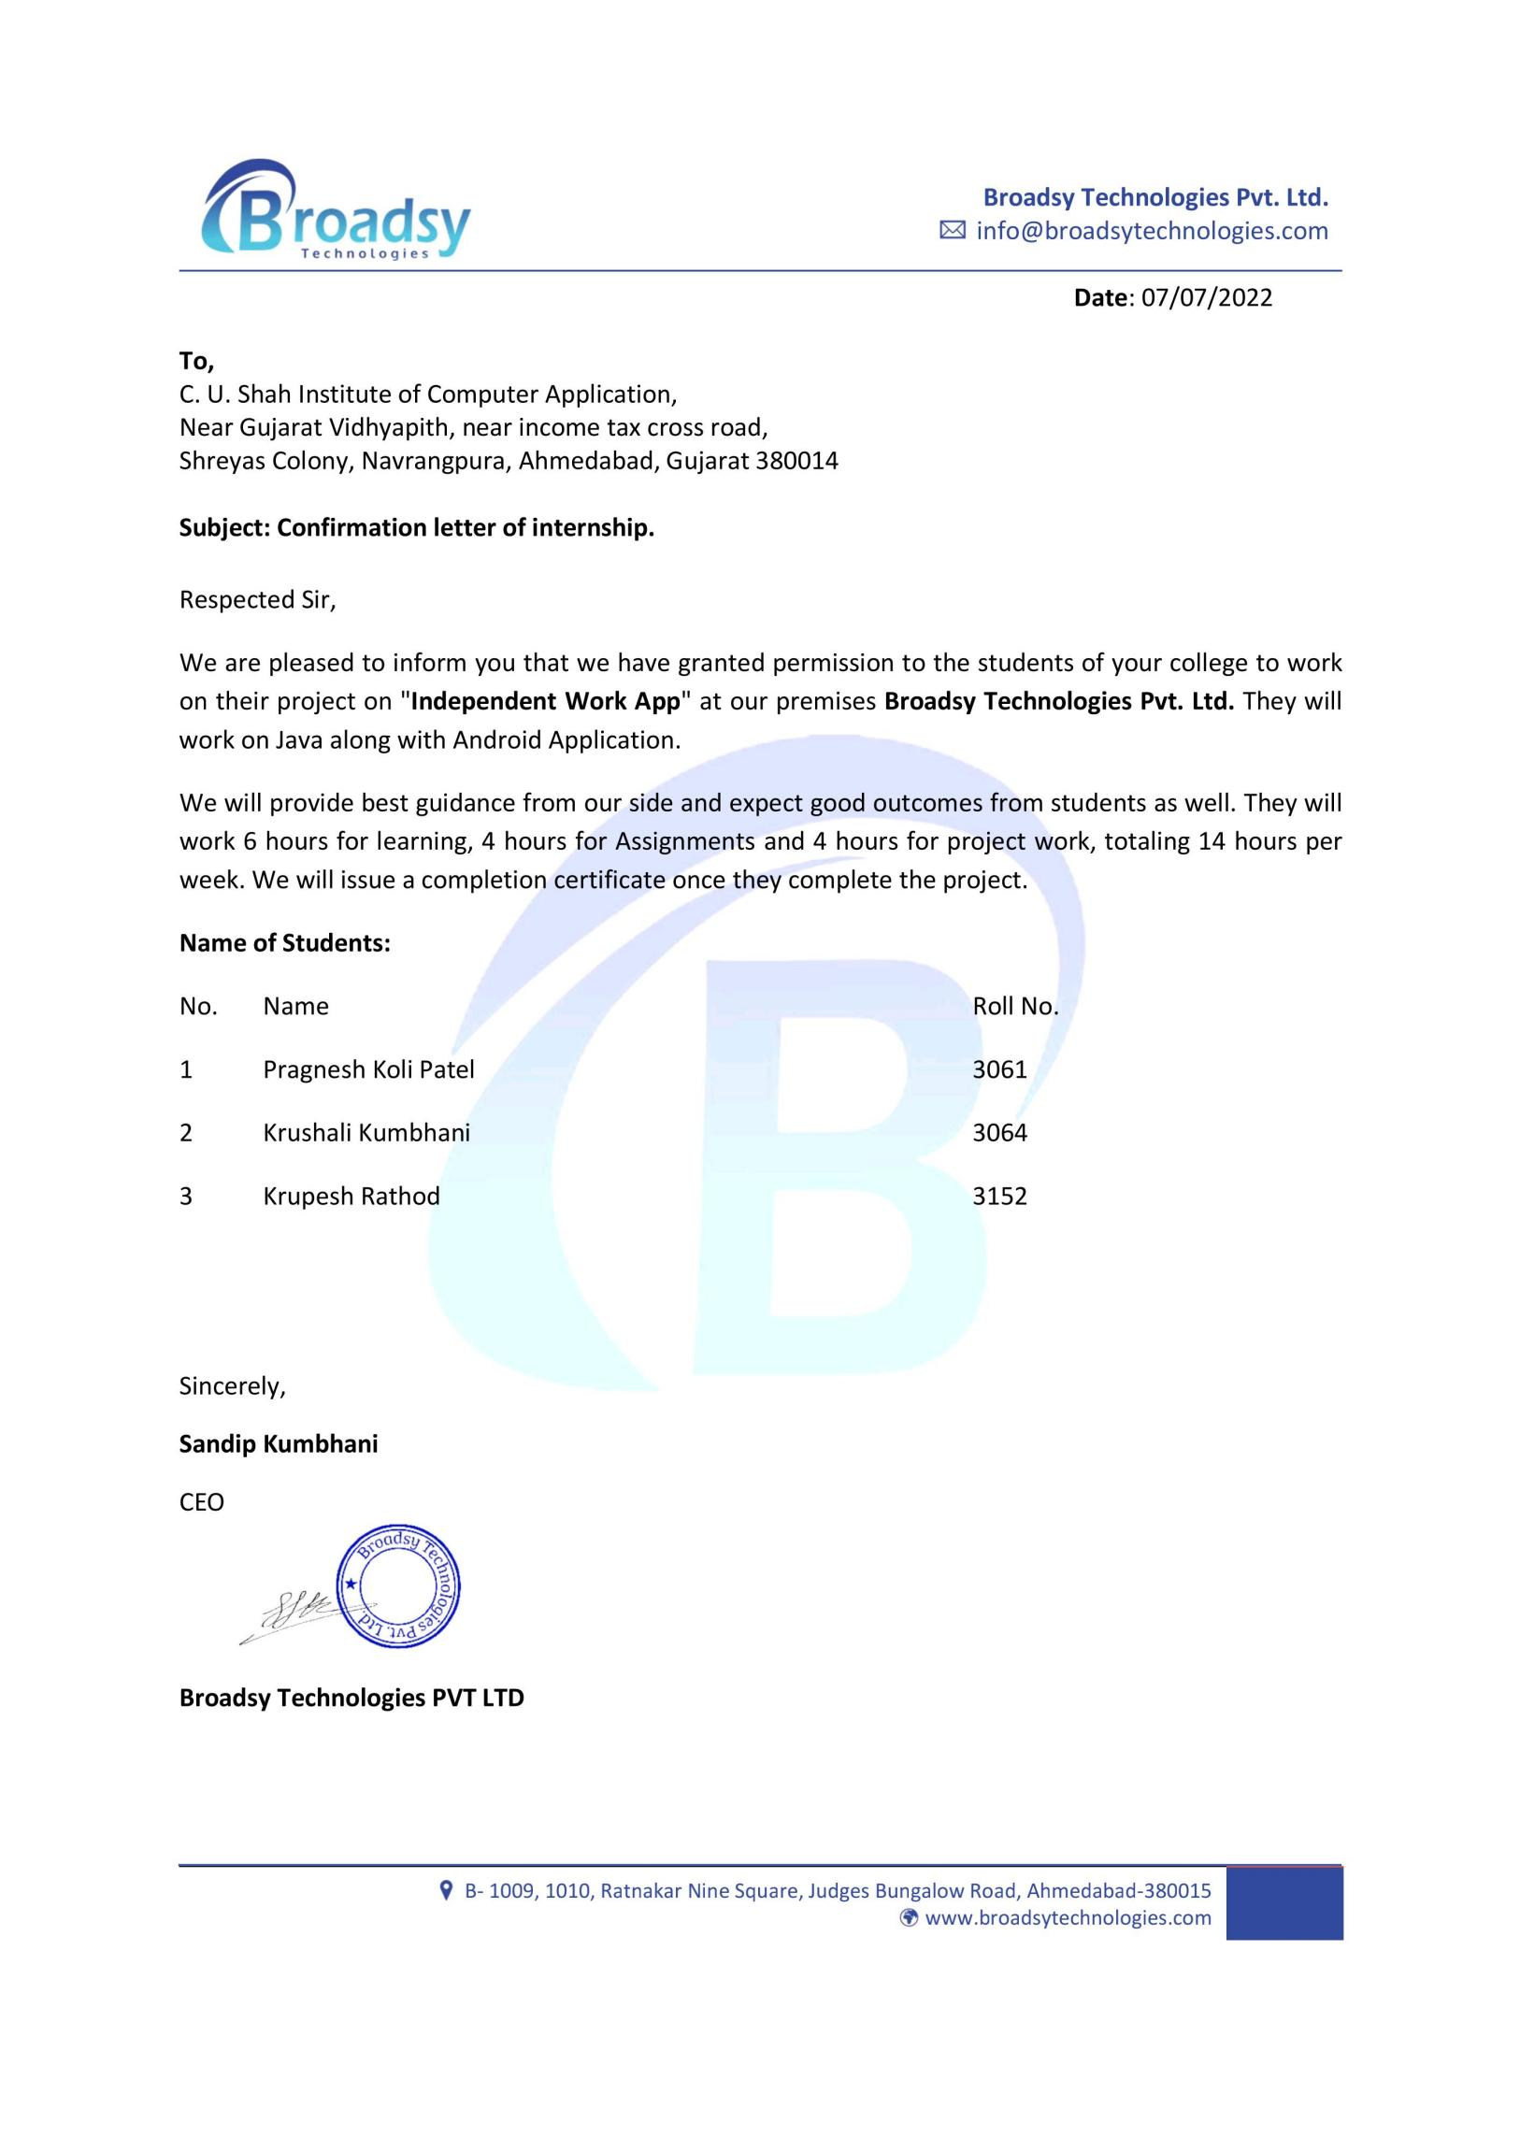

**Acknowledgement**

*The success and final outcome of this project required a lot of guidance and assistance from many people and I am extremely privileged to have got this all along the completion of my project. All that I have done is only due to such supervision and assistance and I would not forget to thank them.*

*We respect and thank* ***Prof. Nilam shrimali*** *for providing me an opportunity to do the project work in* ***C.U. SHAH INSTITUTE OF COMPUTER APPLICATION*** *and giving us all support and guidance, which made me complete the project duly.*

*We owe my deep gratitude to our guide* ***Prof. Nilam shrimali*** *who took keen interest on our project work and guided us all along, till the completion of our project work by providing all the necessary information for developing a good system.*

*Last but not the least we are also thankful to our friends, project, partners, colleagues and parents for support and understanding the provided us during the project work. We are also very much thankful to all who directly or in directly helped us.*

**KOLIPATEL PRAGNESH V. [ 3061 ]**

**KUMBHANI KRUSHALI D. [ 3064 ]**

**RATHOD KRUPESH S. [ 3152 ]**